**Lab Task**

Q1. Print the record of all employees working in department ID 70,90,60.

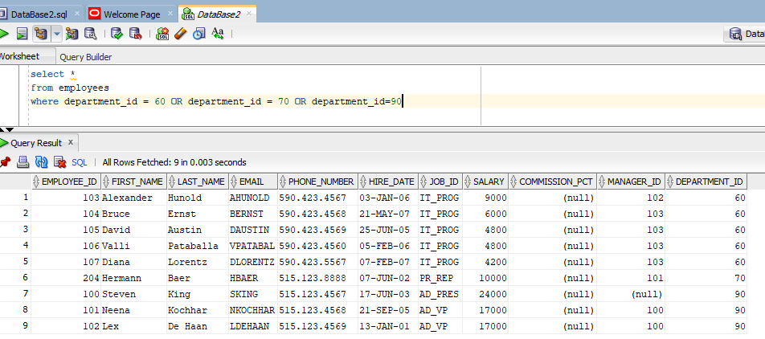

Q2. Print the record of all employees having manager_id 100 and having salary greater than 6000 and display the result in one column as account report.

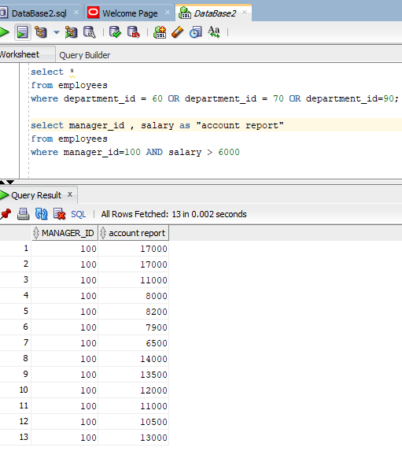

Q3. Print the record of employees having ‘SA’ as starting job_id character.

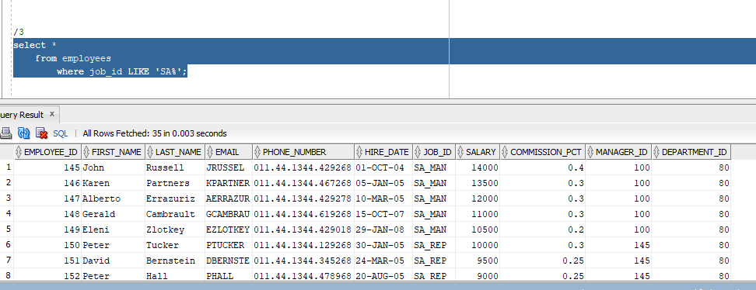

Q4. Print the record of employees who have joined the company after January 11, 2007.

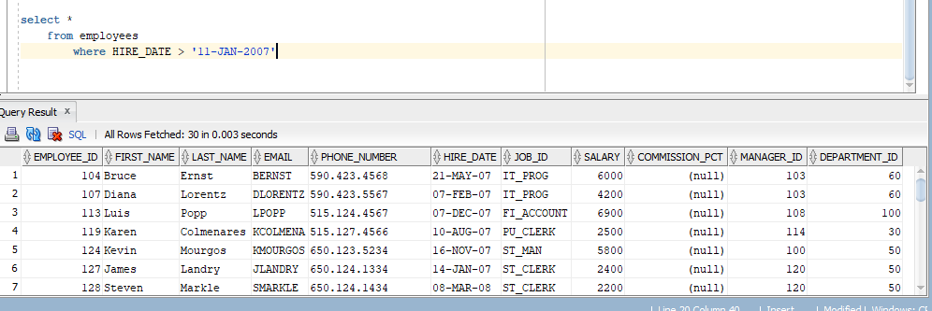

Q5. From Jobs table print print the job title of all the jobs having minimum salary greater than 7000 and maximum salary less than 10000.

Q6. Display the unique names of Job_ids from employee table.

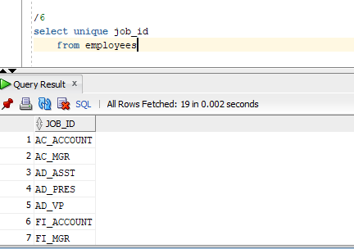

Q7. Is there any employee who is not working in any department if there is print his record.

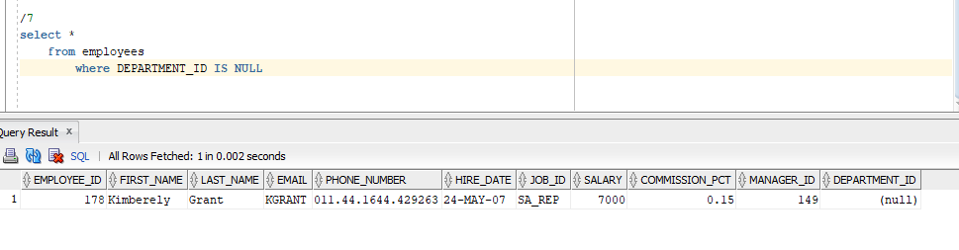

Q8. Print the record of all those employees having job_id SA_MAN or MK_MAN and having salary greater than 9000. (Hint take care of precedence)

